***Dt : 6/5/2022***

***Ex_Program : (Demonstrating methods)***

***class DemoMethods1***

***{***

***static int a=10;***

***int b=20;***

***void m1()***

***{***

***System.out.println("====m1()====");***

***System.out.println("The value a="+a);***

***System.out.println("The value b="+b);***

***}***

***static void m2()***

***{***

***System.out.println("====m2()====");***

***System.out.println("The value a="+a);***

***//System.out.println("The value b="+b);***

***}***

***public static void main(String[] args)***

***{***

***DemoMethods1 ob = new DemoMethods1();***

***ob.m1();***

***DemoMethods1.m2();***

***}***

***}***

***o/p:***

***====m1()====***

***The value a=10***

***The value b=20***

***====m2()====***

***The value a=10***

***=========================================================***

***Diagram:(Demonstrating the Location of methods);***

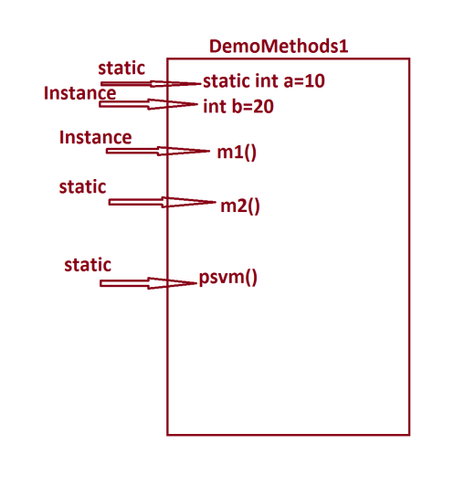

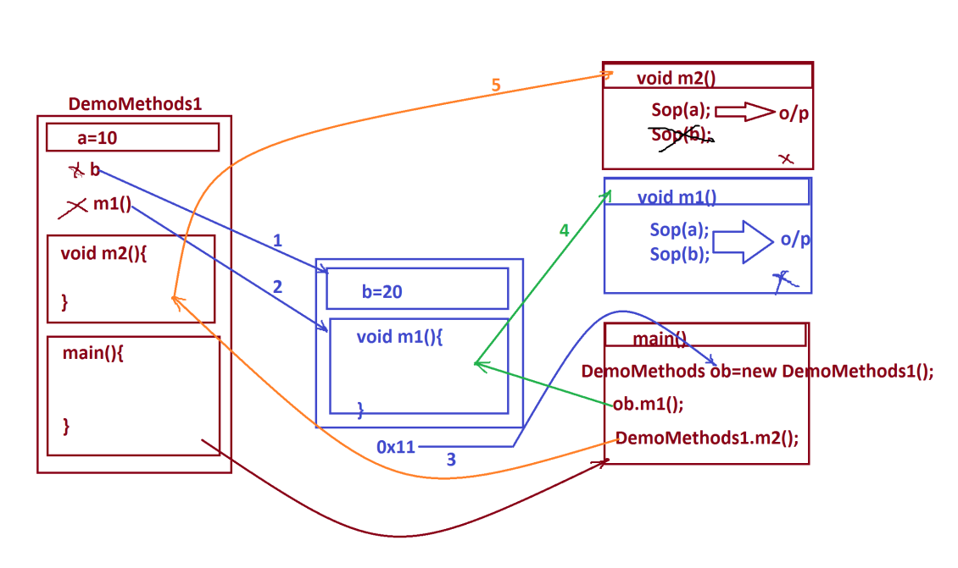

***=======================================================***

***define return_type?***

***=>return_type specify the methods will return the value after***

***method execution or not***

***=>Based on return_type methods are categorized into two types:***

***(i)Non-return_type methods***

***(ii)return_type methods***

***(i)Non-return_type methods:***

***=>The methods which will not return any value after method***

***execution are known as Non-return_type methods.***

***=>The methods which are declared with 'void' are known as***

***Non-return_type methods.***

***Ex:***

***m1(),m2() methods are Non-return_type methods***

***(ii)return_type methods:***

***=>The methods which return the value after method execution are***

***known as return_type methods.***

***=>The methods which are declared without 'void' are know as***

***return_type methods.('void' is replaced with datatype)***

***=>we use 'return' statement to return the value after execution.***

***=>The returned value will come back to the method_call.***

***-------------------------------------------------------------***

***define parameters?***

***=>Parameters are the variables which are used to transfer the***

***data from one method to another method.***

***=>Based on parameters the methods are categorized into two types:***

***(i)Methods without parameters***

***(ii)Methods with parameters***

***(i)Methods without parameters:***

***=>The methods which are declared without parameters are known***

***as Zero Parameter methods or Methods without parameters.***

***Ex:***

***m1() and m2() are Zero parameter methods.***

***(ii)Methods with parameters:***

***=>The methods which are declared with parameters are known as***

***Parameterized methods or Methods with parameters.***

***==========================================================***

***Ex_Program:(Demonstrating methods with parameters)***

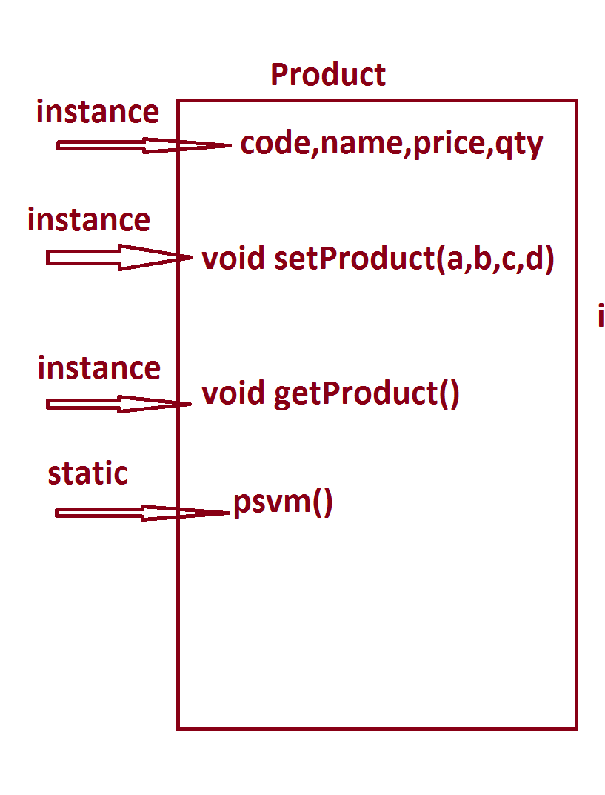

***Program : Product.java***

***class Product***

***{***

***int code;***

***String name;***

***float price;***

***int qty;***

***void setProduct(int a,String b,float c,int d)***

***{***

***code=a;***

***name=b;***

***price=c;***

***qty=d;***

***}***

***void getProduct()***

***{***

***System.out.println("====ProductDetails===");***

***System.out.println("ProdCode="+code);***

***System.out.println("ProdName="+name);***

***System.out.println("ProdPrice="+price);***

***System.out.println("ProdQty="+qty);***

***}***

***public static void main(String[] args)***

***{***

***int pC = 123;***

***String pN = "Mouse";***

***float pP = 123.45F;***

***int pQ = 12;***

***Product p = new Product();***

***p.setProduct(pC,pN,pP,pQ);***

***p.getProduct();***

***}***

***}***

***o/p:***

***====ProductDetails===***

***ProdCode=123***

***ProdName=Mouse***

***ProdPrice=123.45***

***ProdQty=12***

***=======================================================***

***Assignment:***

***wap to display book details?***

***Layout:***



